Troubleshooting error 35250 when trying to JOIN a database to an AlwaysOn Availability Group.

(The connection to the primary replica is not active. Command cannot be processed)

1) Ensure Endpoint is created and started

SELECT tep.name as EndPointName, sp.name As CreatedBy,tep.type_desc,

tep.state_desc, tep.port

FROM sys.tcp_endpoints tep inner join

sys.server_principals sp on tep.principal_id = sp.principal_id

WHERE tep.type = 4

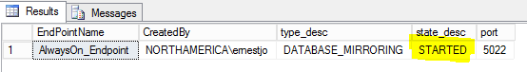

2) Endpoint Listening? (Telnet "Telnet name EndPointPort" or "Telnet IP EndPointPort"

for example if the Endpoint is defined as Server1 (with IP 192.168.1.15) on Port 5022 then try:

Telnet Server1 5022 and/or

Telnet 192.168.1.15 5022

* If the Endpoint is listening, then you should receive a blank screen. If not, you will receive an error from Telnet in trying to connect.
* If it works with IP but not NAME, there could be a DNS / name resolution error of some sort.
* If it works by NAME and NOT by IP, then there could be more than one endpoint on that server (another SQL instance?) that is listening on that port -- so that EVEN THOUGH the status of the endpoint on the instance in question shows "STARTED" another instance may actually have the binding and prevent the instance in question from actually listening and establishing TCP connections.
* If it doesn't connect at all with Telnet, look for Firewall and/or Anti-virus products such as McAfee HIPS or Norton -- "standard" SQL connection troubleshooting elimination but for the endpoint port in question.

3) EndPoint configured for same ip/port that AG is defined for?

* run the following query from the primary (and then each secondary replica if not connecting)

select endpoint_url from sys.availability_replicas

* make sure the port name matches the port defined for the endpoint on each respective replica instance

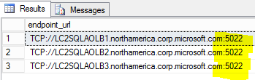

If you are using specific IP addresses for the endpoint to listen on (versus the default of “listen all”, then you may need to have URLs that use the actual specific address rather than the FQDN. The reason for this is because of DNS resolution. If the FQDN is used in the URL, then by default, the GetHostByName call may return the wrong IP address. If it doesn’t return the exact same address as the Endpoint is configured for, then it will timeout trying to connect.

Another way to test this is that Telnet works to the IP but not to the FQDN. So when using specific IPs for the Endpoint Listener rather than Listen “all”, you will have better success in using the IP in the URL rather than FQDN.

4) Make sure service account has permission to EndPoint

* Run the following query to get list of accounts that have connect permission to the Endpoint on the server(s) in question.

SELECT perm.class_desc, prin.name, perm.permission_name,

perm.state_desc, prin.type_desc as PrincipalType,

prin.is_disabled FROM sys.server_permissions perm

LEFT JOIN sys.server_principals prin

ON perm.grantee_principal_id = prin.principal_id

LEFT JOIN sys.tcp_endpoints tep ON perm.major_id = tep.endpoint_id

WHERE perm.class_desc = 'ENDPOINT' AND

perm.permission_name = 'CONNECT' AND

tep.type = 4

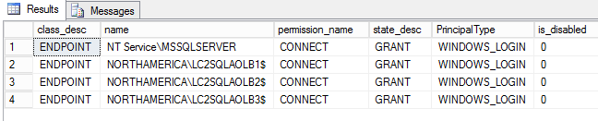

If not, add the permissions. If the service account is a domain user, then:

CREATE LOGIN [domain\acctname] FROM WINDOWS;

ALTER SERVER ROLE SysAdmin ADD MEMBER [domain\acctname] ;

If the service account is [nt authority\system] or [nt authority\mssqlserver] then for EACH node in the cluster do the following. And issue the command for each node – on EACH instance, so that every instance has logins for every node.

CREATE LOGIN [domain\node$] FROM WINDOWS;

ALTER SERVER ROLE SysAdmin ADD MEMBER [domain\node$] ;

5) DNS resolution to wrong IP ?? (using NSLookup) -- try IP/port instead of name/port

* Does the name resolve to the correct IP addres -- try a PING from the server having problems.
* Do a NSLookup for the name - does it show correct address?
* Are there HOSTS file entries?
* Are there client side aliases defined?

6) Capture a NETSTAT -a output and verify there is a LISTENING or ESTABLISHED on the IP:Port

for the endpoint specified.

7) Network captures??